Biology 1120

Laboratory Exercise 2: Microscopy

Work in groups of 2 to 4, using the Zeiss compound microscopes. Read the handout on microscope care that you are given. The scopes are delicate and expensive.

Basics of Microscope Use and Care:

- Always carry the scopes with two hands: one on the arm and one on the base. They are heavy and expensive.
- Make sure the low power objective lens is in place (facing the stage) before you start. Larger lenses could hit the stage and cause damage.
- Rotate the objective lenses by the bezel ring only, never by the lens itself. Grabbing the lens could damage its seating and destroy the focus of the scope permanently.
- When you rotate the objective lenses, watch from the side to ensure they will not hit the slide or the stage.
- Do not wipe microscope surfaces with anything except a Kimwipe or lens paper. Other materials can scratch the fragile optical coating.
- Keep both eyes open and relaxed. Anything else will produce headaches. If the view from one of your eyes seems blurry, use the diopter adjustments to correct the focus for the microscope. The default setting should have the diopter set to the white dot. Adjust the width between eyepieces to a comfortable width.
- When you replace the microscopes in the cupboard, loosely coil the power cords and attach them using the Velcro strips.
- Cover the microscope with its dust cover before you put it back in the cupboard, ensuring that the low power objective lens is facing the stage.
- Do not place the scopes too close to the edge of the desk and do not let power cords dangle over walkways
- Try to place the microscope at a comfortable ergonomic height. We have phone books in the front cupboard that you can use to adjust the heights.

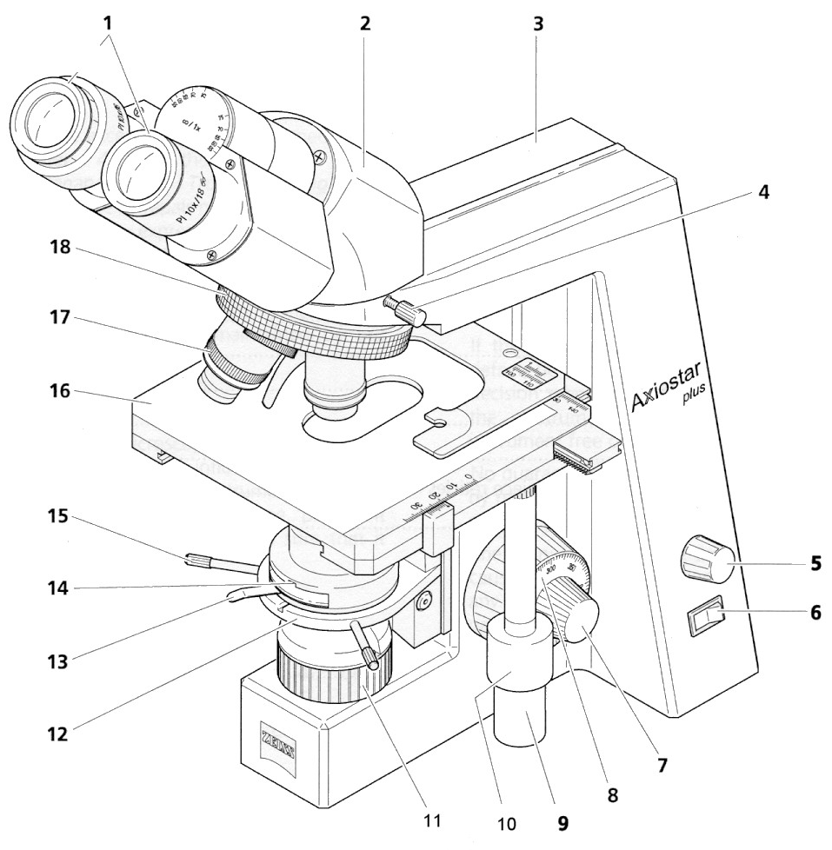

- Eyepieces
- Binocular tube
- Microscope stand or arm
- Knurled screw for tube locking
- Brightness control
- On/off switch with integrated signal lamp
- Fine focusing drive (two-way)
- Coarse focusing drive (two-way)
- Drive for adjusting mechanical stage slide clip in X direction
- Drive for adjusting mechanical stage slide clip in y direction
- Luminous field diaphragm
- Condenser carrier
- Lever for adjusting iris diaphragm
- Condenser
- Centering screw for condenser (two-way)
- Mechanical stage with specimen holder (slide clip)
- Objective
- 4-positions nosepiece

Figure 4. Parts of a Compound Light Microscope. This picture is of the Zeiss Axiostar plus model, but the parts will be similar for many common brands.

A. Preparing a wet mount slide.

Use a small piece of algae (one cell thick is the best - you should be able to see through it with your naked eye) or other specimen as provided in class. Add one drop of water directly onto the specimen. Lower a cover slip gently onto the slide from one side. Bring the cover slip into contact with the water, then gradually ease the slip onto the specimen to reduce air bubbles. If water escapes from the cover slip use a small bit of paper to wick up the excess. Ensure that the bottom side of the cover slip is dry before placing the slide onto the microscope stage.

B. Initial set up and focus for a compound microscope.

Place your slide on the stage using the stage clips. Use the stage guides to place the specimen directly over the light source. Ensure that the low power objective lens is in position over the slide. Bring your specimen into focus with the coarse and then fine focussing knobs. The best way to do this is to raise the stage as close as possible to the specimen watching the objective lens all the time (and NOT looking into the oculars) to make sure that the lens does not run into the slide. Then rotate the focus knob to lower the stage while looking through the oculars to bring the specimen into focus (details are as sharp as they can be). If you are having difficulty with focussing, it can sometimes help to use the edge of the cover slip as an item to obtain a rough focus.

Keep the light fairly low for best viewing (about 30% of maximum is usually best). Once the slide is in focus at low power, you shouldn’t need to use the coarse focus again, as all other objective lenses should also be in focus.

- Which magnification has the largest field of view (visible area)?
- Which magnification has the smallest depth of view (vertical region in focus at one time)?
- Which magnification is best for locating objects on the slide? An efficient way to locate objects is to use the stage guides. Begin in one corner of the cover slip. Scroll across to the opposite side, then scroll up or down by one field of view. Scroll back across the cover slip to the opposite side. Continue this scrolling until you have viewed the entire cover slip.

C. Setting up a compound microscope for Köhler illumination

In order to get the best image possible from a compound light microscope, the light path needs to be set up properly. The procedure is called Köhler illumination after August Köhler, the man who invented it. Essentially, this involves adjusting the diaphragms and condensers to improve the focussing of light onto the stage. Proper Köhler illumination should provide an evenly lit bright image without glare and minimise heating of specimens. Ensure that everyone in your group can set up Köhler illumination. If your group does not have a Zeiss microscope, merge with one that does for part C.

To set up Köhler illumination:

- Switch on the light. Place your specimen on the stage and use the low power objective lens to bring the slide into focus.

- Rotate the medium power objective carefully into place and adjust the focus as necessary. Close the diaphragm on the base of the microscope as far as possible. This diaphragm adjusts the size of the illuminated field of view. At this point you want to see a sharply focussed hexagonal or octagonal shape in the centre of the field of view that has a purple or blue edge to it. The field around this shape should be evenly dark. If this is not the case you will need to adjust the condenser.
- If the octagon is blurred: Raise the condenser as far as you safely can by using the condenser focus knob underneath the stage. While looking through the ocular lenses, slowly lower the condenser. When the field of view (aperture) is at its smallest, the edges of the octagon should also be sharpest. Adjust the condenser focus to make the edges as sharp as possible. As well, the edges should be blue or purple tinged instead of orange or yellow (this colour around the opening is scattered light which needs to be minimised).

- If the octagon is not centred: When this happens, the condenser has been jarred from its central position. Ask one of the instructors to help with this adjustment as a mistake could damage the condenser.

- If the area around the octagon is not evenly dark: To reduce this glare, close down the diaphragm in the condenser (note that this is a second diaphragm, not the one you had previously closed) until all of the dark area outside of the silhouette is evenly dark.
- Open up the field diaphragm on the base of the microscope until the edge of the diaphragm silhouette is outside the field of view.

- Switch to the high power objective lens and make any further refinements to the focus of the condenser.

D. Drawing objects under the microscope.
Biological illustration has a long history. A number of conventions have arisen to ensure scientific accuracy.

- Shading is either left out, so that only outlines of objects are shown, or if included, are done only by stippling (individual dots) to keep the drawings clear.

- Labels are printed and kept at a uniform size. Lines from a part of the drawing to that object should not cross and should be parallel to each other whenever possible.

- Whenever possible, use a soft lead pencil for drawing.

- Make your drawing large enough to include as much detail as you can see, typically at least a quarter or third of a page.

- Unless otherwise instructed, draw only what you actually see, not what an illustration in a text or other source shows.

- Keep your drawing to the left-hand side of the page to allow space on the right-hand side for labels.

- Provide a caption for your drawing beneath your sketch.

- Showing the magnification of the drawing or indicating the true size of the specimen is an essential component of the caption. We will calculate these items in the next section.

- Objects viewed under a microscope are often drawn in a circle that represents the edges of the field of view, but this is not essential.

Draw and label what you see under your microscope as accurately as possible.

E. Calculating sizes and magnifications for specimens.

Calculations of this sort are usually best estimates unless some fairly expensive tools such as micrometers or haemocytometers are used. The most common way to calculate microscopic object sizes is to compare a specimen to an item of known size such as the field of view of the microscope. We can measure the field of view of the microscope with a ruler or a slide holding a metric scale.

The size of an object under the microscope is simply:

Size of object = 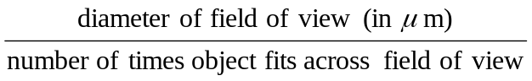

Unless you are otherwise instructed, base your size estimates of objects on the longest measurement of the object.

The size of the field of view can be measured directly with a ruler or micrometer slide for low or medium power. For high power, the size of the field of view can be calculated based on the size at lower magnifications. As magnification increases, the field of view decreases. This is a simple linear relationship. If magnification increases tenfold, then the field of view shrinks tenfold. Thus, if we know the size of the field of view at any magnification, we can calculate it for others.

Some of the microscopes have ocular rulers or micrometers built into the eyepieces. These rulers have lines etched into the glass, but do not provide an absolute scale, since the objective lens can vary. While the use of a scale on the stage is still the most accurate means of measurement, the ocular scale can be useful. The following table provides approximate sizes of the scale for differing magnifications. Note that in this table 1 unit of the ocular scale is the distance from one number to the next on the scale (the scale goes from 0 to 10). There are also smaller subdivisions visible on the ruler, but the table provides the sizes for each major unit.

Table 1. Size of one unit on an ocular micrometer scale at various objective lens magnifications for a Zeiss microscope.
Objective lens magnification | Size of one unit (in μm).
5X | 200
10X | 100
40X | 25
100X | 10

Once we know the actual size of an object we can calculate the magnification of a drawing of that same object. Measure the size of your drawing and convert the measurement into micrometers (μm). Divide the size of your drawing by the actual size of the object and you have the magnification of your drawing. For instance, if a drawing is 20 cm across, it is 200,000 μm. If the actual specimen was 50 μm in length, then the magnification of the drawing is 200,000 divided by 50, a magnification of 4000 times.

Magnification of drawing = 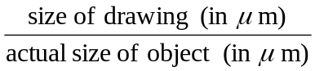

Calculate the size of your drawing and include this measurement in the caption for your drawing.

Try the following problems in microscopic calculation. Note that the values in the questions may not be the same as for the microscopes you have used:

- If the magnification of the objective lens is 40X and the ocular lens is 10X, what is the total magnification of the microscope image?
- If the ocular lens is 10X and the objective lens is 100X (oil immersion), what is the total magnification?
- The field of view at low power (50X magnification) is 3.6 cm by measurement. What is the size of the field of view in micrometers? What would be the size of the field of view at medium power (100X)?
- The field of view at medium power (100X) is 1.75 cm by measurement. What would be the size of the field of view at high power (400X)? How big would the field of view be using the oil immersion lens (1000X)?
- The field of view at medium power is 1.75 cm. You estimate that 7 objects can fit across the field of view. How big is the object?
- The field of view at medium power is 1.75 cm. At high power, you estimate that 12 objects will fit across the field of view. How big is the object?
- You estimate the size of an object as 150 micrometers. You produce a drawing that is 10 cm across. What is the magnification of your drawing?
- You estimate the field of view as 3.6 cm at low power (50X). At high power (objective lens only = 40X) you estimate that 5 objects will span the field of view. You produce a drawing that is 27 cm across. What is the magnification of your drawing?

F. Staining specimens.

There are many ways of staining specimens to improve visibility of details. Some stains can be used with live specimens, while others work only with dead objects. Many stains are noxious chemicals that require special care to prevent damage. A few (such as picric acid) are even explosive if not used properly.

Some of the common stains are:

Crystal Violet - used for bacterial staining, plant chromatin and animal nerve tissue

Eosin - for showing blood cells and some cell components

Giemsa - for showing different types of white blood cells

Hematoxylin - for nucleus components

Methylene Blue - for bacteria, mitochondria and nerve cell components

Sudan Black - for fatty structures, golgi bodies, chromosomes and leukocyte grains

Wright Stain - for blood components.

Prepare a wet mount slide of your cheek cells by lightly rubbing the inside of your cheek with a toothpick. Smear the sample on a clean slide and place one drop of crystal violet or methylene blue onto the smear. Use a cover slip as usual. If there is too much stain, wick away the excess by holding a small scrap of absorbent paper to the edge of the cover slip. Draw what you see under the microscope.

G. Using a Dissecting Microscope.

The compound microscopes that we have been using so far are the best for viewing small, thin specimens such as we can mount on a microscope slide. In many instances, however, we will need to provide magnification of very large specimens such as dissected body parts or other specimens such as plants or animals. For these large, thick objects, a dissecting microscope (also known as a stereomicroscope) is the best bet. These are just variations on a standard compound light microscope. They have lower magnification levels but can accommodate large objects for viewing. Our dissecting microscopes are also from Zeiss.

Use of this microscope is fairly simple. Place an object on the insert plate. Since the stands for these microscopes are plastic and easily scratched, never place a metal dissecting tray on this stand. Only use a plastic tray.

Switch the light on by pressing the illumination control. You can determine how your object is lit by repeatedly pressing this control. It cycles through reflected light only (light comes from the source above the object), transmitted light only (light comes from below the object), both reflected and transmitted light, and no light (other than from the general surroundings). Choose whichever light mode works best for you. The plus and minus buttons will increase and decrease the intensity of the light sources.

Look through the eyepieces and adjust their separation to ensure you see a single image. With the magnification adjustment at the lowest power (8X), focus on the object using the focussing knob. Increase the magnification as required. The highest magnification is 32X.

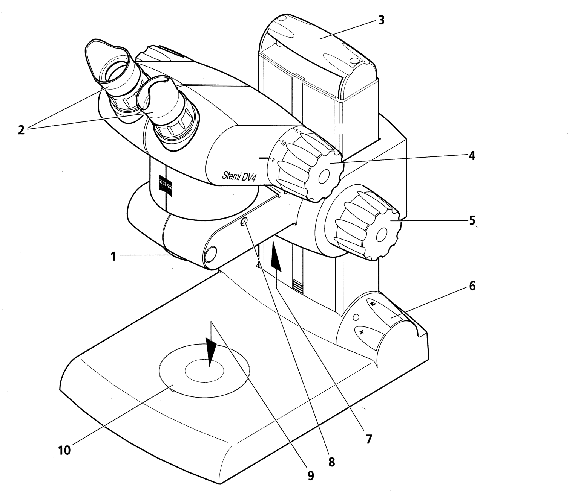

- Connector for accessories
- Eyepieces with folding eyecups
- Carrier handle
- Magnification adjustment
- Focus knob
- Illumination control
- Reflected light illuminator
- Clamping screw (anchors the head to the stand)
- Transmitted light illuminator
- Insert plate for object mounting

Figure 5. Parts of a Dissecting Microscope. The microscope in this diagram is a Zeiss model.

