Photosynthesis and cellular respiration

Cellular respiration and photosynthesis are direct opposite reactions. Energy from the sun enters a plant and is converted into glucose during photosynthesis. Some of the energy is used to make ATP in the mitochondria during cellular respiration, and some is lost to the environment as heat

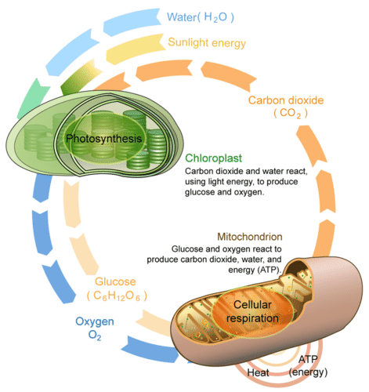

Summary of Photosynthesis
- The chemical equation for photosynthesis is
- 6CO₂+6H₂O→C₆H₁₂O₆+6O₂.
- In plants, the process of photosynthesis takes place in the mesophyll of the leaves, inside the chloroplasts.
- Chloroplasts contain disc-shaped structures called thylakoids, which contain the pigment chlorophyll.
- Chlorophyll absorbs certain portions of the visible spectrum and captures energy from sunlight.

Terms
- chloroplast: An organelle found in the cells of green plants and photosynthetic algae where photosynthesis takes place.
- mesophyll: A layer of cells that comprises most of the interior of the leaf between the upper and lower layers of epidermis.
- stoma: A pore in the leaf and stem epidermis that is used for gaseous exchange.

Overview of Photosynthesis
Photosynthesis is a multi-step process that requires sunlight, carbon dioxide, and water as substrates. It produces oxygen and glyceraldehyde-3-phosphate (G3P or GA3P), simple carbohydrate molecules that are high in energy and can subsequently be converted into glucose, sucrose, or other sugar molecules. These sugar molecules contain covalent bonds that store energy. Organisms break down these molecules to release energy for use in cellular work.

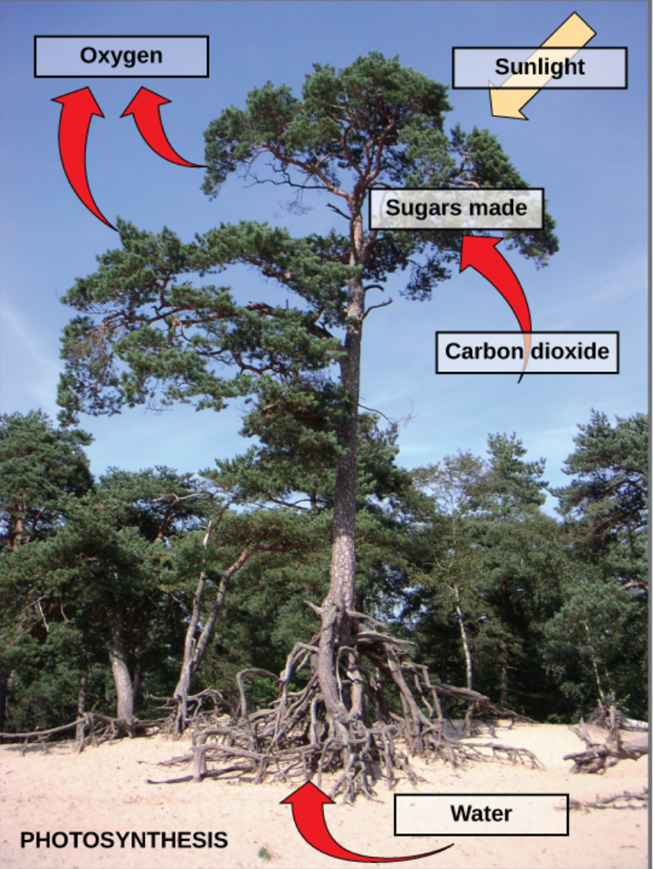

The energy from sunlight drives the reaction of carbon dioxide and water molecules to produce sugar and oxygen, as seen in the chemical equation for photosynthesis. Though the equation looks simple, it is carried out through many complex steps. Before learning the details of how photoautotrophs convert light energy into chemical energy, it is important to become familiar with the structures involved.
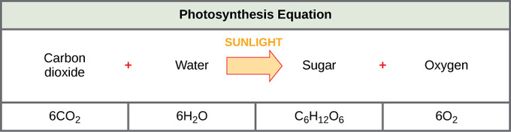

Chemical equation for photosynthesis: The basic equation for photosynthesis is deceptively simple. In reality, the process includes many steps involving intermediate reactants and products. Glucose, the primary energy source in cells, is made from two three-carbon GA3P molecules.

Photosynthesis and the Leaf
In plants, photosynthesis generally takes place in leaves, which consist of several layers of cells. The process of photosynthesis occurs in a middle layer called the mesophyll. The gas exchange of carbon dioxide and oxygen occurs through small, regulated openings called stomata (singular: stoma ), which also play a role in the plant’s regulation of water balance. The stomata are typically located on the underside of the leaf, which minimizes water loss. Each stoma is flanked by guard cells that regulate the opening and closing of the stomata by swelling or shrinking in response to osmotic changes.
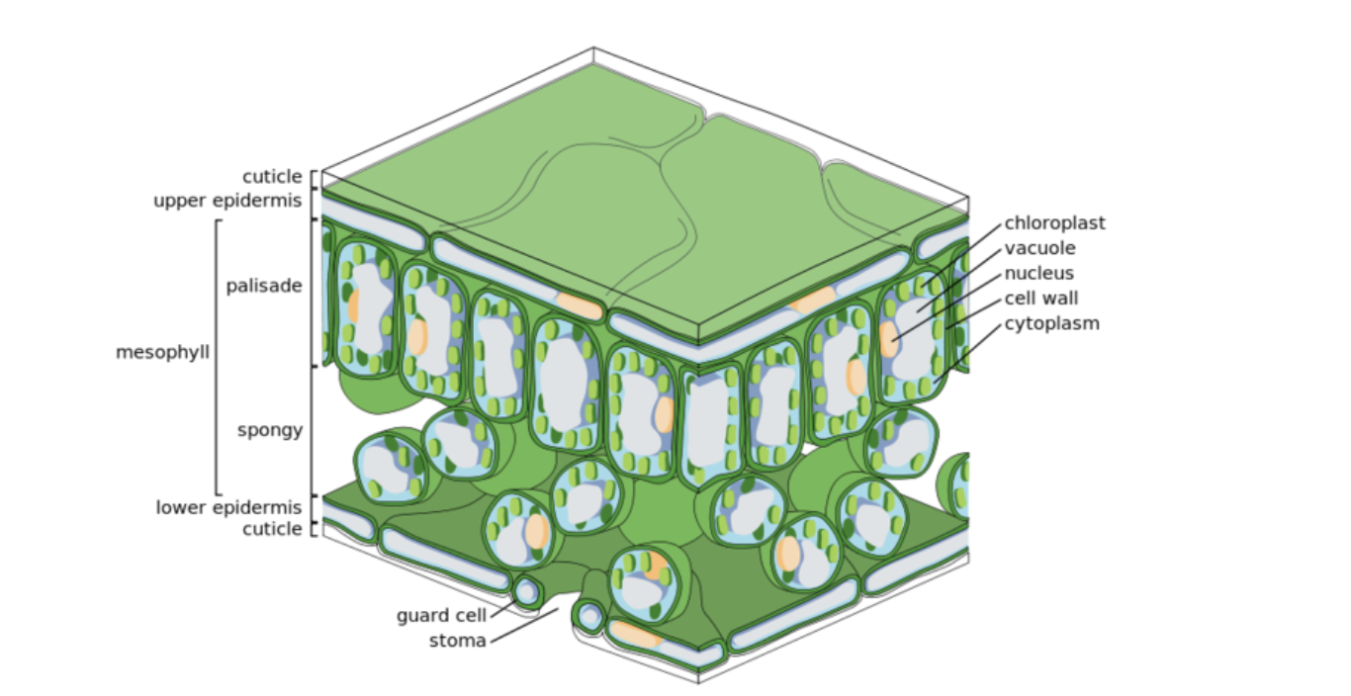

Structure of a leaf (cross-section): Photosynthesis takes place in the mesophyll. The palisade layer contains most of the chloroplast and principal region in which photosynthesis is carried out. The airy spongy layer is the region of storage and gas exchange. The stomata regulate carbon dioxide and water balance.

Photosynthesis within the Chloroplast
In all autotrophic eukaryotes, photosynthesis takes place inside an organelle called a chloroplast. For plants, chloroplast-containing cells exist in the mesophyll. Chloroplasts have a double membrane envelope composed of an outer membrane and an inner membrane. Within the double membrane are stacked, disc-shaped structures called thylakoids.
Embedded in the thylakoid membrane is chlorophyll, a pigment that absorbs certain portions of the visible spectrum and captures energy from sunlight. Chlorophyll gives plants their green color and is responsible for the initial interaction between light and plant material, as well as numerous proteins that make up the electron transport chain. The thylakoid membrane encloses an internal space called the thylakoid lumen. A stack of thylakoids is called a granum, and the liquid-filled space surrounding the granum is the stroma or “bed.”
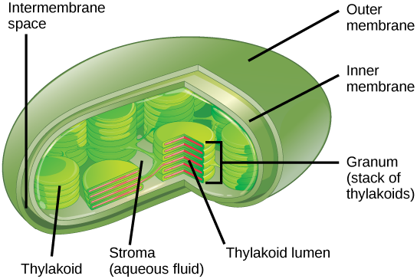

Structure of the Chloroplast: Photosynthesis takes place in chloroplasts, which have an outer membrane and an inner membrane. Stacks of thylakoids called grana form a third membrane layer.

Light-Dependent Reactions
Just as the name implies, light-dependent reactions require sunlight. In the light-dependent reactions, energy from sunlight is absorbed by chlorophyll and converted into stored chemical energy, in the form of the electron carrier molecule NADPH (nicotinamide adenine dinucleotide phosphate) and the energy currency molecule ATP (adenosine triphosphate). The light-dependent reactions take place in the thylakoid membranes in the granum (stack of thylakoids), within the chloroplast.
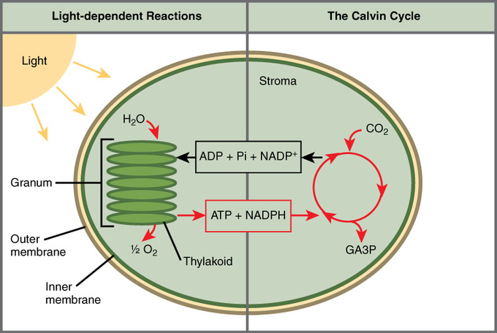

The two stages of photosynthesis: Photosynthesis takes place in two stages: light-dependent reactions and the Calvin cycle (light-independent reactions). Light-dependent reactions, which take place in the thylakoid membrane, use light energy to make ATP and NADPH. The Calvin cycle, which takes place in the stroma, uses energy derived from these compounds to make GA3P from CO2.

Photosystems
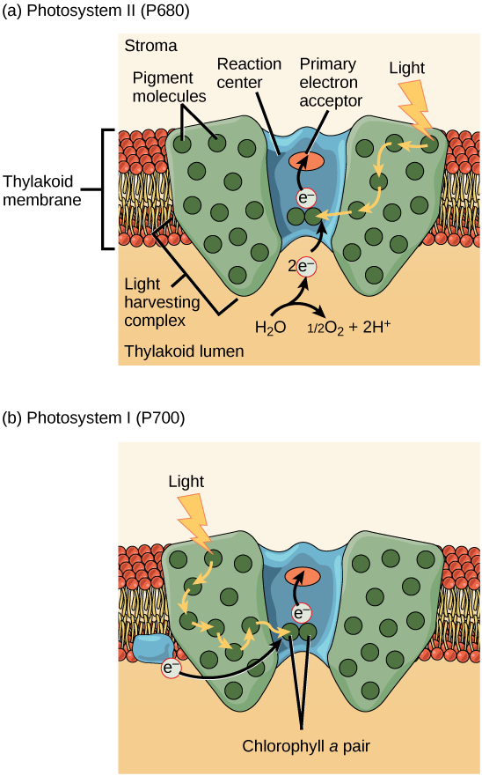

Photosystems I & II: As explained above, the photosystems manipulate electrons with energy harvested from light.
The process that converts light energy into chemical energy takes place in a multi-protein complex called a photosystem. Two types of photosystems are embedded in the thylakoid membrane: photosystem II ( PSII) and photosystem I (PSI). Each photosystem plays a key role in capturing the energy from sunlight by exciting electrons. These energized electrons are transported by “energy carrier” molecules, which power the light-independent reactions.
Photosystems consist of a light-harvesting complex and a reaction center. Pigments in the light-harvesting complex pass light energy to two special chlorophyll a molecules in the reaction center. The light excites an electron from the chlorophyll a pair, which passes to the primary electron acceptor. The excited electron must then be replaced. In photosystem II, the electron comes from the splitting of water, which releases oxygen as a waste product. In photosystem I, the electron comes from the chloroplast electron transport chain.
The two photosystems oxidize different sources of the low-energy electron supply, deliver their energized electrons to different places, and respond to different wavelengths of light.

Light-Independent Reactions
In the light-independent reactions or Calvin cycle, the energized electrons from the light-dependent reactions provide the energy to form carbohydrates from carbon dioxide molecules. The light-independent reactions are sometimes called the Calvin cycle because of the cyclical nature of the process.
Although the light-independent reactions do not use light as a reactant (and as a result can take place at day or night), they require the products of the light-dependent reactions to function. The light-independent molecules depend on the energy carrier molecules, ATP and NADPH, to drive the construction of new carbohydrate molecules. After the energy is transferred, the energy carrier molecules return to the light-dependent reactions to obtain more energized electrons. In addition, several enzymes of the light-independent reactions are activated by light.
Source:

https://bio.libretexts.org/Bookshelves/Introductory_and_General_Biology/Book%3A_General_Biology_(Boundless)/8%3A_Photosynthesis/8.1%3A_Overview_of_Photosynthesis/8.1C%3A_The_Two_Parts_of_Photosynthesis

