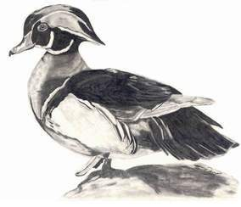
Vancouver Community College
Biology 1100
Field trip: Stanley Park Bird Diversity

Objective: This field trip will introduce you to the diverse feathered residents of a small coastal British Columbia Lake ecosystem. You will identify B.C. and migratory bird species, take field research notes and form hypotheses linking bird behaviour to habitat selection.

You will need: Appropriate clothing, notebook paper, clipboard & pencil, good walking shoes, and a bird identification book (or attached PDF from SPES). Optional: camera. If you have binoculars, please bring them. If you don’t, let me know.

In advance: Look through the attached bird monitoring guide from the Stanley Park Ecology Society and see how it is organized. Many bird- identification books group birds into different categories such as shorebirds, wading birds and passerines (songbirds). These may be further divided into finer groups.

Birds we are likely to see on the trip:

Double-crested cormorant
Canada goose
Pied-billed grebe
Northern shoveler
Wood duck
Mallard duck
House sparrow
Song sparrow
American robin
Swainson’s thrush
Pileated woodpecker
Northern flicker
Black-capped chickadees
Glaucous-winged gull
Starlings
Spotted towhee
Dark-eyed junco

Attached is also a bird checklist for British Columbia. This is a starter kit for you! When we identify different species in the field, check them off on your list. Birders (never call them bird-watchers) are a rare breed and like to find as many different species as possible.

Submit (one week after the field trip):

- Field notes (particularly on bird behaviour and habitat).
- Include a summary of the trip (one paragraph ~ 50-75 words)
- Formulate a connection between bird feeding behaviour and habitat choice.
- MAP TO STANLEY PARK

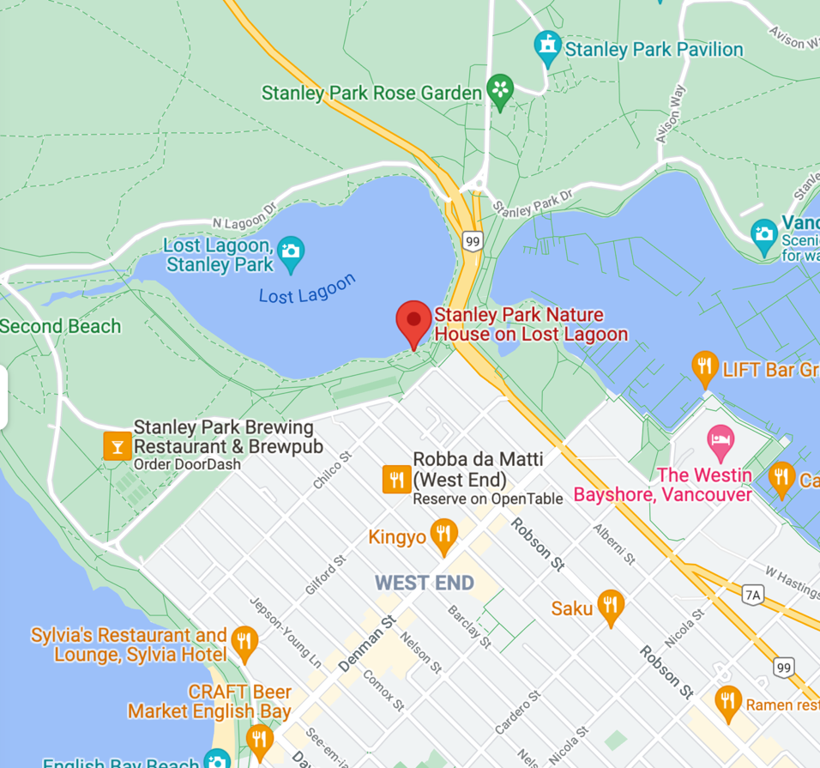

Drivers: There is parking across from tennis courts (the closest parking to the lagoon). We are meeting at Chilco and Alberni near Lost Lagoon – there is a small grassy area there that is right above the Nature House. If you’re late you will find us walking around Lost Lagoon (starting on the south side going counterclockwise)

Transit: The # 19 bus will get you to the bus stop on Pipeline Road. From there you can walk and meet us above the Nature House. Alternatively, you can take a bus to Robson and Denman and walk from there.

Here are some good bird identification books .

Birds of Canada / Fred J. Alsop III. Author Alsop, Fred. Publisher Toronto : Dorling Kindersley, 2002. Call # QL 685 A47 2002

Common birds of British Columbia / J. Duane Sept. Author Sept, J. Duane, Publisher Sechelt, B.C. : Calypso Pub., c2003. Call # QL 685.5 B7 S47 2003

Field guide to the birds of North America / [Mary B. Dickinson, editor]. Author National Geographic Society Publisher Washington, D.C. : National Geographic, 2002 Call # QL 681 F53 2002

A bird-finding guide to Canada / edited by J. Cam Finlay. Publisher Toronto : M&S, 2000. Call # QL 685 B57 2000

Birds of North America / Kenn Kaufman ; with the collaboration of Rick and Nora Bowers and Lynn Hassler Kaufman. Author Kaufman, Kenn. Publisher New York : Houghton Mifflin, c2000. Call # QL 681 K36 2000

